For Side Effects, if I choose “Other Side Effects”, there is not button after that to click.

I thought we had discussed this.

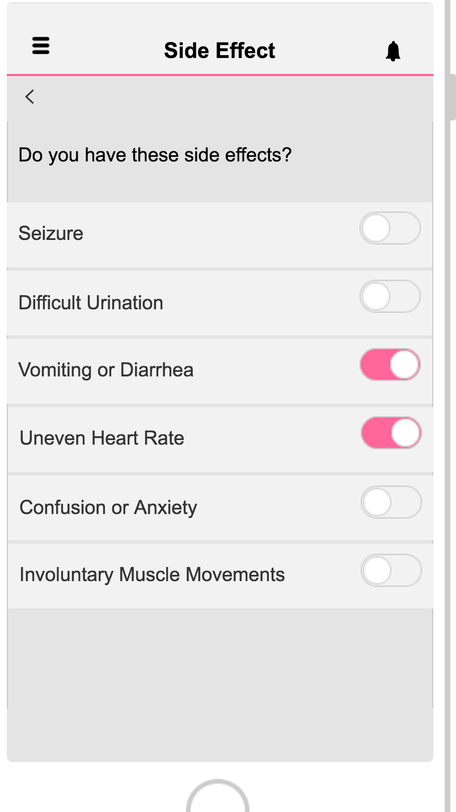

1. Please list the following less serious side effects here:

* Mild skin rash or itching
* Loss of interest in sex
* Dry mouth
* Blurred vision
* Urinating less than usual

2. add both “Submit” and “No Side Effects” buttons here

3. If the user clicks on “No Side Effects”, go to the same page you use for the other “No Side Effects” click

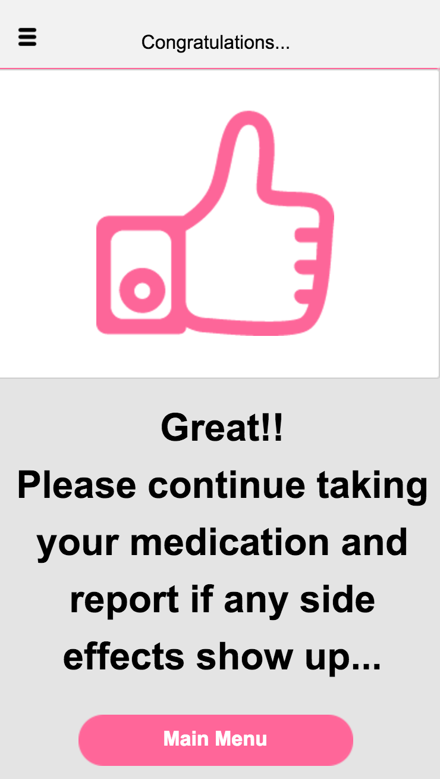

4. If the user chooses any of these side effects and clicks submit, it should say

“Your Doctor has been informed. Please continue taking your medications and discuss your side effects with your doctor in your next visit”

On the main menu, if I click on Alarm, it shows “Please Answer Some Short Questions” but when I click on that message, it shows the page about “Adjust posture to avoid fall!”

* Please change it so instead it takes the user to the Questionnaire page

For the speech Recording, instead of the current text that you have, put:

“Detecting vocal qualities that accompany or often proceed the onset of the disease’s disabling physical symptoms may make it possible to intervene earlier on in the degenerative process. Although most of our speech processing will occur in the background via Auto Tracker, this section may utilize some verbal question and answers as well”

Under Homa Care logo in the main page say “Good Day Jeff”

In My Condition:

1. The section for Manage bipolar disorder looks unprofessional with the run on…

* end your paragraph after “help watch you for bipolar symptoms” and take the rest out

2. The section for “Contact your health care provider or psychiatrist if” also looks like it’s running over. Move it up a little bit and maybe change the fonts to fit things in, or remove 1-2 bullets.

1. If I choose “Fun and Relaxation” from the side menu, it goes to the wrong menu from the past and the new “Fun & Relaxation” page that you created.

Please make sure it goes to the new Fun & Relaxation page.

2. If I click on “Questionnaire” from the side menu it goes to the new Fun & Relaxation page..It should instead go to the Questionnaire page.

(please keep Questionnaire in the same location on the menu since it’s more important than the Fun & Relaxation” page

Also on the Parkinson’s TPT, can you make sure that the alarms work well and if we click on the alarms it takes us to the correct pages?

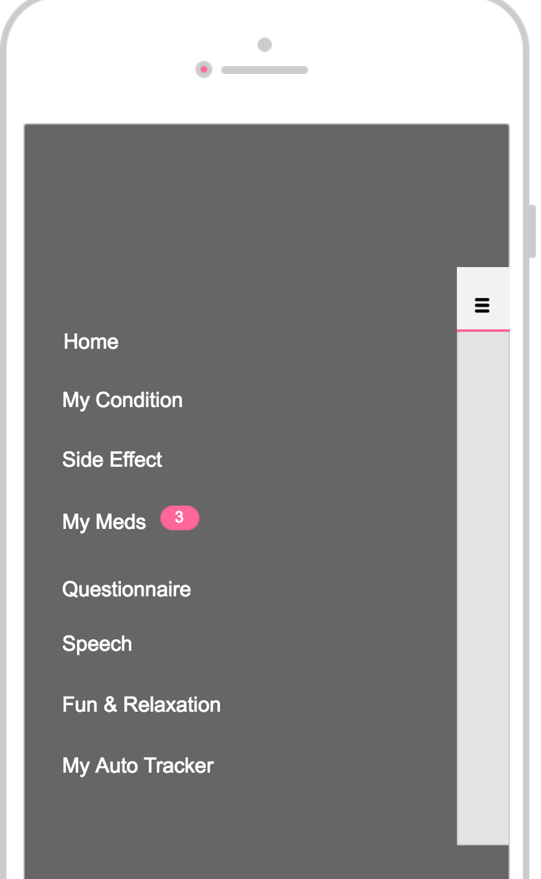

If I click on “Questionnaire” from the side menu it goes to the new Fun & Relaxation page..It should instead go to the Questionnaire page.